**Creating Roles**

In this demo, you create roles. Roles provide model database object and data security by limiting access to only those users that are role members. Each role is defined with a single permission: None, Read, Read and Process, Process, or Administrator. Roles can be defined during model authoring by using Role Manager. After a model has been deployed, you can manage roles by using SQL Server Management Studio (SSMS).

You can create three roles:

* **Sales Manager** – This role can include users in your organization for which you want to have Read permission to all model objects and data.
* **Sales Analyst US** – This role can include users in your organization for which you want only to be able to browse data related to sales in the United States. For this role, you use a DAX formula to define a *Row Filter*, which restricts members to browse data only for the United States.
* **Administrator** – This role can include users for which you want to have Administrator permission, which allows unlimited access and permissions to perform administrative tasks on the model database.

## **Creating Roles**

#### To create a Sales Manager user role

1. In Tabular Model Explorer, right-click **Roles** > **Roles**.

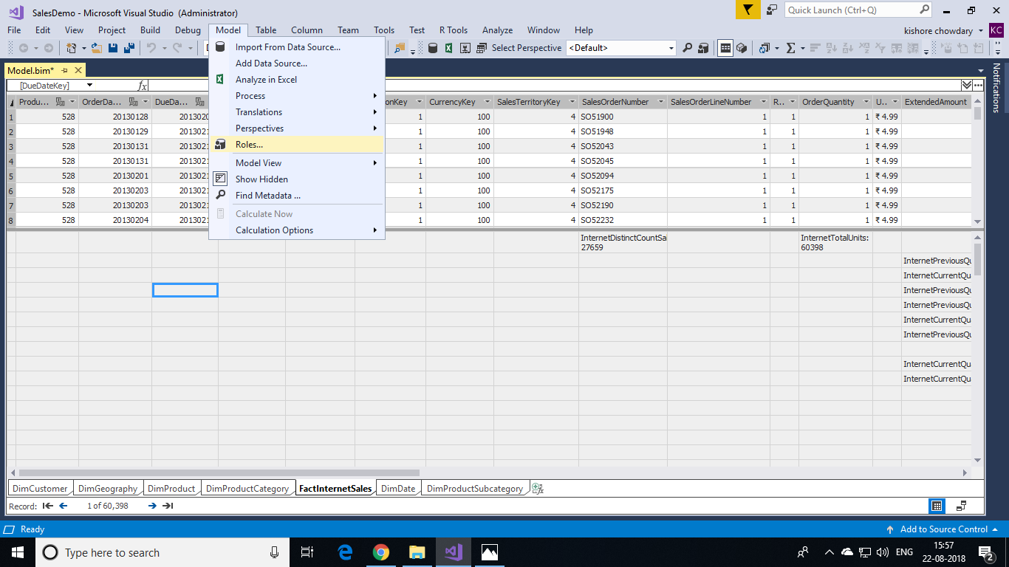

1. In Role Manager, click **New**.

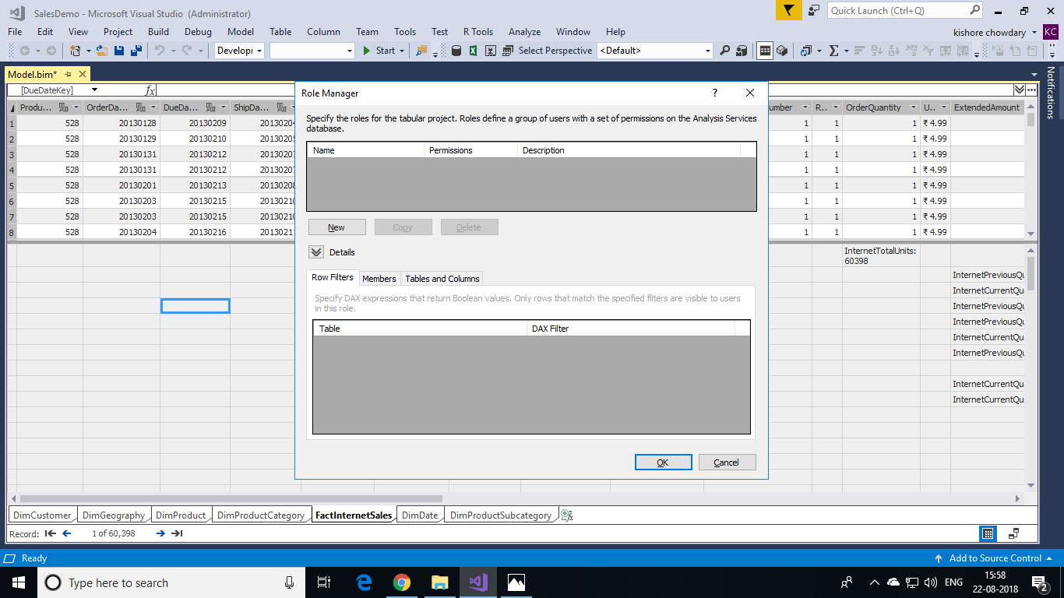

1. Click the new role, and then in the **Name** column, rename the role to **Sales Manager**.
2. In the **Permissions** column, click the dropdown list, and then select the **Read** permission.

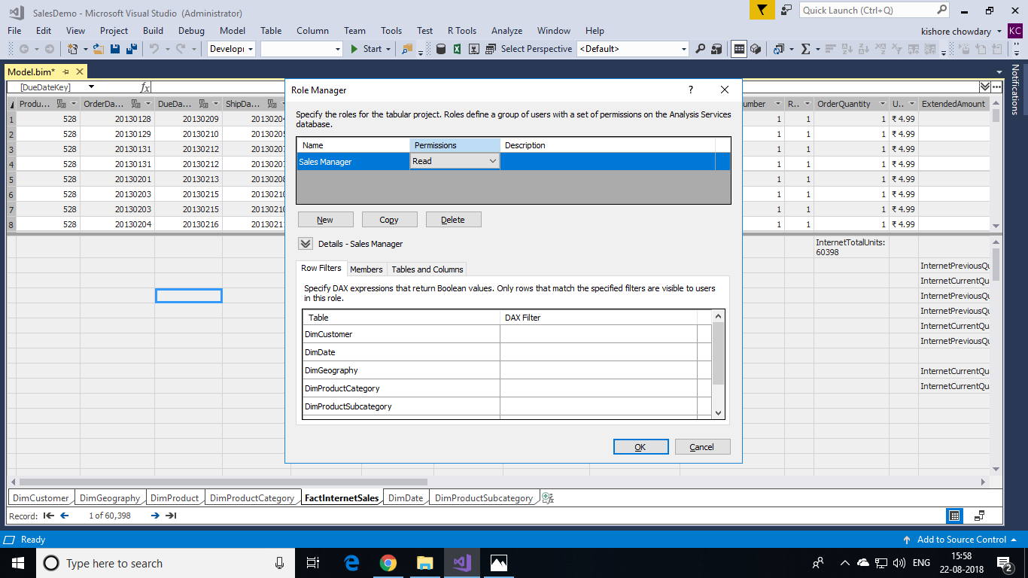

#### **Creating a Sales Analyst US user role**

1. In Role Manager, click **New**.
2. Rename the role to **Sales Analyst US**.
3. Give this role **Read** permission.
4. Click the Row Filters tab, and then for the **DimGeography** table only, in the DAX Filter column, type the following formula:

=DimGeography[CountryRegionCode] = "US"

A Row Filter formula must resolve to a Boolean (TRUE/FALSE) value. With this formula, you are specifying that only rows with the Country Region Code value of “US” are visible to the user.

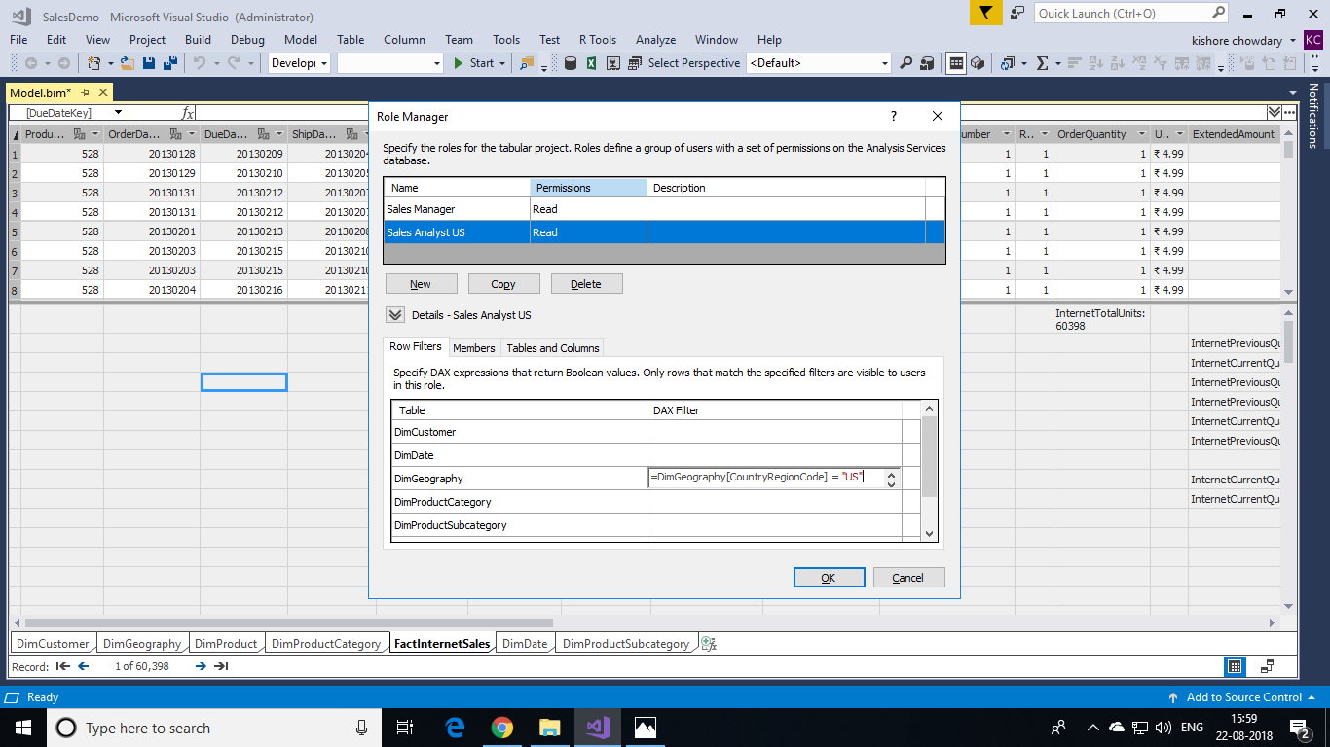

#### **Creating an Administrator user role**

1. Click **New**.
2. Rename the role to **Administrator**.
3. Give this role **Administrator** permission.
4. Optional: Click the **Members** tab, and then click **Add**. In the **Select Users or Groups** dialog box, enter the Windows users or groups from your organization you want to include in the role.